Experience the local flavor of southwest PA
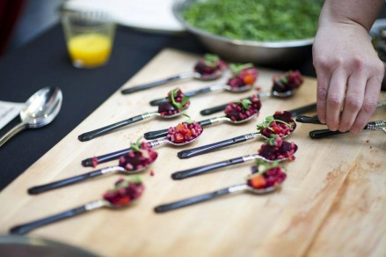
The Friday Night Local Food Tasting is a casual gathering that allows consumers to experience first-hand the quality and diversity of locally grown, produced and prepared food. It will be held in conjunction with the 9th Annual Farm to Table Pittsburgh Conference.
We are expecting 500 local food enthusiasts. This is a great event to meet local Pittsburghers who value their food and are excited to learn how to access local food and beverages. The atmosphere is relaxing: music and local food conversation abounds.
Visit “Farm to Table Pittsburgh” on Facebook and Twitter for photos, event updates and program details.

Where we came from…
American HealthCare Group started the Farm to Table Local Food Conference in 2007. Throughout the year we sponsor programs to increase the awareness and availability of real, local food to area consumers.

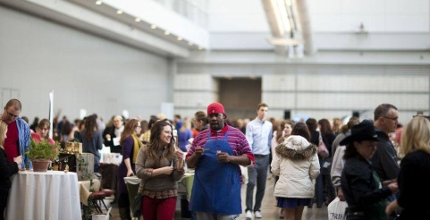
Participate in the Tasting
There is no cost to exhibit at this tasting event! If you are a grower or producer of local food, wine or beer you can sign up to participate in the tasting. You can sell packaged food, products, gift certificates, etc at the event.

Get Your Name Out There!
Program advertising is available for a sponsorship fee and we include recipes from participating organizations for free. You are not obligated to exhibit at the tasting event in order to advertise in the event program.
Vendor Registration includes: Exhibit table w/linens provided; Listing in Event Program; Inclusion in promotional campaigns; Individual tagging on social media; Live link on website;

Advertising and Sponsorship
Program Ads
Full Page: $500
Half Page: $275
Quarter Page: $175

Full page ad: 4.755”w x 7.6875”h
Half page ad: 4.755”w x 3.755”h
Quarter page ad: 2.295”w x 3.755”h
Product Sponsor – In-kind local food products
This sponsorship includes food producers, farms, distributors and retailers who can provide ingredients to local chefs.
- Name & logo on website
- Name & full page ad in Event Program
Local Food Tasting Sponsor - $5,000
Customized Exhibit space
Name & full page ad in Event Program
Exhibit space at 2015 Farm to Table Conference: March 27 & 28, 2015
Company name on website
Social media campaign on Farm to Table

Exhibitor Registration:
Please list all information as you would like it to be presented in the Event Program. Deadline: March 1, 2015
Program info:
Company Name: _________________________________ Phone: __________________ City/State: _______________
Contact info:
Contact Name: ___________________________Phone:____________________ Email: __________________________
Contact Email: _____________________________________ Website: __________________________________________
# of Tables: __________ # of Chairs:_______# of Attendees at table: _______ Electricity Needed? YES __ NO __
Other Needs: __________________________________________________________________
Menu Item (s) to be available at the tasting: (Product sponsors, list available ingredients and quantities)
________________________________________________________________________________________________________
Tasting Vendors are expected to supply any paper products needed to serve your food/beverage tasting sample –ie. Napkins, plates, cups, spoons, etc. 500 samples should be available for the tasting.
Participating Wineries must apply for and acquire a Limited Winery Exposition permit to pour and sell their wine at the event.
Participating Breweries and Distilleries must have a Levy bartender pour their drinks. Our sponsor, American HealthCare Group, is covering all costs of the bartender so that any brewery or distillery can participate at no charge.

Please return this form or contact us with questions:
Liz Kanche – Director, Wellness Services: Phone: 412-563-7854; Cell: 412-818-2328
Fax: 412-563-8319
Email: LHKanche@american-healthcare.net
Mail: 1910 Cochran Road, Manor Oak One, Suite 405, Pittsburgh, PA 15220
Payment for Advertisements and Sponsorships: Payment is due when you submit this contract. If payment has been received, and a paid exhibitor must cancel; no refund will be issued. If a vendor is late to an event without prior notice, the reserved table may or may not be available upon arrival.
Choose your Payment Method:
_____ Check enclosed (please make checks payable to (American HealthCare Group, LLC)
_____ Credit Card ____Visa ____AmEx ____MC ____Discover Security Code on back: ___________
Credit Card Number: ____________________________________________ Expiration Date: ________________
Credit Card Payment address (No PO Box): _________________________________________________ ZIP: ___________
Cardholder Signature: X__________________________________________________

