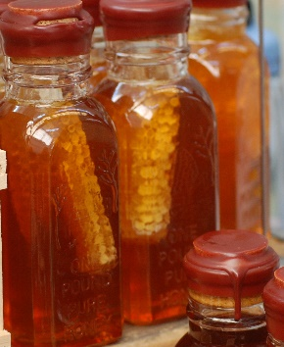
Local Food Tasting
American HealthCare Group has organized the Farm to Table Conference every spring since 2007. Throughout the year we sponsor programs to increase the awareness and availability of real, local food to area consumers. The next Farm to Table Conference will be held Friday & Saturday, March 27 & 28, 2015.

Farm to Table pulls together Local Food Tasting events to allow consumers to experience first-hand the quality and diversity of locally grown, produced and prepared food. We are expecting 750 local food enthusiasts. This is a great event to meet local Pittsburghers who value their food and are excited to learn how to access local food and beverages. The atmosphere is relaxing: music and local food conversation abounds.

Participate in the Tasting
There is no cost to exhibit at this tasting event! If you are a grower or producer of local food, wine or beer you can sign up to participate in the tasting. You can sell packaged food, products, gift certificates, etc at the event.
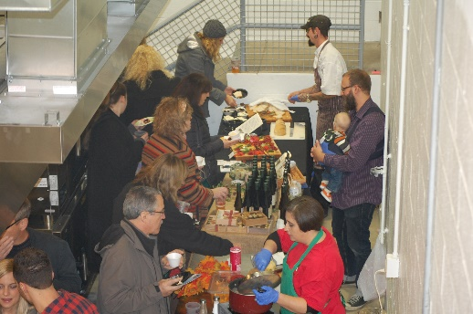
Vendor Registration includes:

- Exhibit table
- Listing in Event Program
- Inclusion in promotional campaigns
- Individual tagging on social media
- Live link on website

Event Program
Program advertising is available. We will also include recipes from participating organizations. You are not obligated to exhibit at the tasting event in order to advertise in the event program. You can check out past event programs here: http://www.farmtotablepa.com./

Advertising and Sponsorship
Product Sponsor – In-kind local food products
This sponsorship includes food producers, farms, distributors and retailers who can provide ingredients to local chefs.
- Name & logo on website
- Name & full page ad in Event Program

Local Food Tasting Sponsor - $5,000
- Customized Exhibit space
- Name & full page ad in Event Program
- Exhibit space at 2014 Farm to Table Conference: March 27 & March 28, 2015
- Company name on website
- Social media campaign on Farm to Table
Program Ads

Full Page: $500
Half Page: $275
Quarter Page: $175

Full page ad: 4.755”w x 7.6875”h
Half page ad: 4.755”w x 3.755”h
Quarter page ad: 2.295”w x 3.755”h

Exhibitor Information:
Please list all information as you would like it to be presented in the Event Program.
Program info:
Company Name: ____________________________________________ Phone:______________ City/State: _______________

Contact info:
Contact Name: ___________________________________Phone:______________Email: ___________________________

Contact Email: ____________________________ Website:____________________________

# of Tables: __________ # of Chairs:__________ # of Attendees at table:___________ Electricity Needed? YES: ___ NO: ____

Other Needs: __________________________________________________________________

Menu Item (s) to be available at the tasting: (Product sponsors, list available ingredients and quantities)

_______________________________________________________________________________________________________

_______________________________________________________________________________________________________

*Please attach your favorite recipe featuring local food that we may print in the program.

Tasting Vendors are expected to supply any paper products needed to serve your food/beverage tasting sample –ie. Napkins, plates, cups, spoons, etc. At least 500 samples should be available for the tasting.

Participating Wineries must apply for and acquire a Limited Winery Exposition permit to pour and sell their wine at the event. This event is a Farmers Market.

Please return this form or contact us with questions:
Erin Hart, Director, American HealthCare Group/Farm to Table
Phone: 412-563-7807 or 412-657-3028
Fax: 412-563-8319

Email: ehart@american-healthcare.net
Mail: 1910 Cochran Road, Manor Oak One, Suite 405, Pittsburgh, PA 15220

Payment for Advertisements and Sponsorships
Payment is due when you submit this contract. If payment has been received, and a paid exhibitor must cancel; no refund will be issued. If a vendor is late to an event without prior notice, the reserved table may or may not be available upon arrival

Choose your Payment Method:
_____ Check enclosed (please make checks payable to (American HealthCare Group, LLC)
_____ Credit Card ____Visa ____AmEx ____MC ____Discover Security Code on back: ___________

Credit Card Number: ____________________________________________ Expiration Date: ________________
Credit Card Payment address (No PO Box): _________________________________________________ ZIP: ___________
Cardholder Signature: X__________________________________________________

