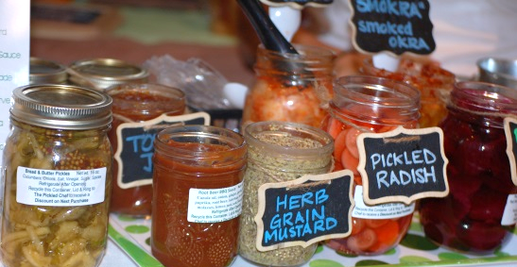
FARM TO TABLE PITTSBURGH: WHO WE ARE Farm to Table Pittsburgh started in 2007 and we’ve held a Local Food Conference every spring at the end of March. Throughout the year we sponsor programs to increase the awareness and availability of real, local food to area consumers. This fall we are hosting the Wine & Cheese (+more!) Happy Hour and the 4th Annual Harvest Tasting. Save the Date! The next Farm to Table Pittsburgh Conference will be held Friday & Saturday, March 18 & 19, 2016.

The Farm to Table Tasting events are casual gatherings that allow consumers to experience first-hand the quality and diversity of locally grown, produced and prepared food. These are great events to meet local Pittsburghers who value their food and are excited to learn how to access local food and beverages. The atmosphere is relaxing: music and local food conversation abounds.

FOLLOW US ONLINE Check out our Facebook page and picture albums: http://on.fb.me/1MkYzGl or visit our Twitter profile: Twitter.com/FTT_Pittsburgh

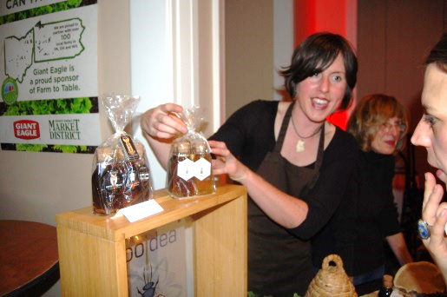
PARTICIPATE IN THE TASTING There is no cost to exhibit at the tasting events! If you are a grower or producer of local food, wine, beer or spirits you can sign up to participate in the tastings. You can sell packaged food, products, gift certificates, etc. at the event. You must provide small tastings to the attendees.

VENDOR REGISTRATION INCLUDES:
- Free Exhibit table provided
- Listing in Event Program
- Live link on website

ADVERTISE IN EVENT PROGRAM Get your business name in front of everyone at the tasting with a program ad. Our programs are like mini-cookbooks with recipes submitted by vendors and sponsors, so attendees are more likely to keep them in their kitchen, where you’ll stay top-of-mind. You can advertise without being a vendor, too. You can check out past event programs here: http://bit.ly/1J6yzxN

ADVERTISING & SPONSORSHIP
PRODUCT SPONSOR In-kind local food products
This sponsorship includes food producers, farms, distributors and retailers who can provide ingredients to local chefs.
- Name & logo on website
- Name & full page ad in Event Program
- Inclusion in promotional campaigns
- Individual tagging on social media

TASTING SPONSOR $5,000/event
- Customized Exhibit space
- Name & full page ad in Event Program
- Exhibit space at 2016 Farm to Table Conference: March 18 & 19, 2016
- Company name on website
- Social media campaign on Farm to Table channels
PROGRAM AD PRICING

Full Page: $500
Half Page: $275
Quarter Page: $175

PROGRAM AD SPECS
All ads must be submitted as .jpg or .pdf. Add .5” bleed sizes below

Full page: 5.5”w x 8.5”h
½ Page: 5.5”w x 4.25”h
¼ Page: 5.5”w x 2.125”h
or 2.25”w x 4.25”h

INDICATE WHICH EVENTS YOU WILL BE EXHIBITING AT WITH FOOD SAMPLES (Registration is Free)
 | Wine & Cheese (& more!) Happy Hour |  | 4th Farm to Table Pittsburgh Harvest Tasting |  | Both

EXHIBITOR INFORMATION: Please list all information as you would like it to be presented in the Event Program.
PROGRAM LISTING:
Company Name: ____________________________________________ Phone: ___________________ City/State: _____________

CONTACT INFO:
Contact Name: ____________________________________________________ Phone: ___________________________________
Contact Email: _________________________________________ Website:_______________________________________________
# of Tables: __________ # of Chairs:__________ # of Attendees at table: ________ Electricity Needed? YES: ___ NO: ____

Other Needs: _____________________________________________________________________________________________________

Menu Item(s) to be available at the tasting and printed in program: (Product sponsors, please list available ingredients and quantities)

_______________________________________________________________________________________________________

_______________________________________________________________________________________________________

*Please attach your favorite recipe featuring local food that we may print in the program.
TASTING VENDORS are expected to supply any paper products needed to serve your food/beverage tasting sample – i.e. Napkins, plates, cups, spoons, ice etc. At least 500 samples should be available for the tasting. Be creative and think of sustainable serving options like lettuce leaves or biodegradable cutlery.
PARTICIPATING WINERIES must apply for and acquire a Limited Winery Exposition permit to pour and sell their wine at the event. This event type is a Farmers Market.
PLEASE RETURN THIS FORM OR CONTACT US WITH QUESTIONS:
Erin Hart, Director, American HealthCare Group/Farm to Table Pittsburgh
Phone: 412-563-7807 or 412-657-3028
Fax: 412-563-8319
Email: ehart@american-healthcare.net
Mail: 1910 Cochran Road, Manor Oak One, Suite 405, Pittsburgh, PA 15220

PAYMENT FOR ADVERTISEMENTS AND SPONSORSHIPS
Payment is due when you submit this contract. If payment has been received, and a paid exhibitor must cancel; no refund will be issued. If a vendor is late to an event without prior notice, the reserved table may or may not be available upon arrival
Choose your Payment Method: _____ Check enclosed (payable to American HealthCare Group, LLC)
_____ Credit Card ___Visa ____AmEx ____MC ____Discover Security Code on back: ___________
Credit Card Number: ________________________________________________________ Expiration Date: __________________
Credit Card Payment address (No PO Box): _________________________________________________ ZIP: ________________
Cardholder Signature: X_________________________________________________________________________________________

