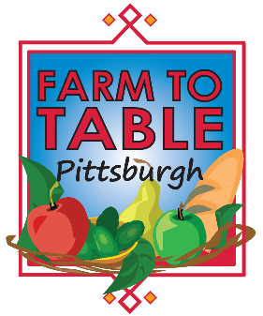
2016 Exhibitor Agreement for Farm to Table Vendor Marketplace
Three Day Blow: August 26 & 27, 2016; 11 am – 4 pm both days
August Wilson Center, 900 Liberty Avenue, Pittsburgh, PA 15222

Three Day Blow - Bringing together over 300 food & drink writers, editors, makers, and explorers from around the country for a Pittsburgh-based conversation about regional food and drink systems in a raucous, literary three day event. The Vendor Marketplace will be open to the public. Farm to Table Pittsburgh will be inviting the Pittsburgh region to sample & buy from vendors.

Payment is due when you submit this contract. If payment has been received, and a paid exhibitor must cancel; no refund will be issued. If a vendor is late to the event without prior notice, the reserved table may or may not be available upon arrival.
Questions? (412)657-3028 Fax: (412)563-8319
Pay by Check: Checks payable to: American Health Fairs, 1910 Cochran Road, Manor Oak One, 405, Pittsburgh, PA 15220
Pay with Credit:  Credit will be processed under the name American HealthCare Group. Your credit card bill will reflect this. | Credit Card Type: | Visa MasterCard American Express
 | Card Number: |  | Exp Date:
 | Name on card: | Security Code:
SIGN HERE: ___________________________________________________________ DATE:______________________
BASIC CONTACT INFORMATION
Company: |  |  |  |  |  |  |  | Contact Name:
Address: |  |  |  |  |  |  |  | City/State/Zip:
Phone#: |  |  |  | Fax#: |  |  |  | Email:
# extra tables: ($350 each) |  |  |  | # of chairs: |  |  | Electricity? |  | Yes No
Description of Table Presentation
Registration includes:
- 6 foot table
- Name in program
- Name and link on website
- Inclusion in pre event & post event social media

Email Newsletters: $500
Directory Feature $150
Blog Feature $75
Farm to Table Pittsburgh
Digital Advertising (per month)
- Customized Exhibit space
- Name & full page ad in program
- Name and logo on website
- Digital Advertising in Emails & Social Media
- Event Signage
- Inclusion in event promotions
- Develop customized promotions

Full Page (5.5”w X 8.5”h) $500
½ Page (5.5”w X 4.25”h) $275
¼ Page (5.5”w X 2.25”h) $150
Ads should be submitted at 300 dpi with .25” bleed. Acceptable file formats are .png, .jpg, or .pdf.

Program Advertising
Featured Sponsors: $5,000
Exhibitor Fee - $350
PAYMENT INFORMATION
Total Fees:
Exhibitor/Sponsor Fee ___________
Discount ___________
Ad Fee ___________
Electricity ___________
Extra Tables ($350 each) ___________
Corner Booth ($100) ___________
Sponsor ($5,000) ___________
Email Ads: qty._______ x $500 =___________
Directory Ads: qty.____ x $150 =___________ Blog Feature: qty.______ x $75 =___________
Total: ___________
SPONSORSHIP & EXHIBITOR LEVELS

