Company Information
Company Name |  |  |  | Contact Name
Physical Address
County |  |  |  | Work Phone
Social media accounts |  |  |  | Mobile Phone
Social media accounts |  |  |  | Fax
Website Address |  |  |  | Email Address
Membership Type
 | Allegheny County Businesses |  |  |  | $300
 | Western PA Businesses |  |  |  | $150
 | Supporting Consumers (Annual Event Attendance Included) |  |  |  | $150
 | Sponsorships |  |  |  | Call
Business Information
Description of Business

What products do you grow/make?
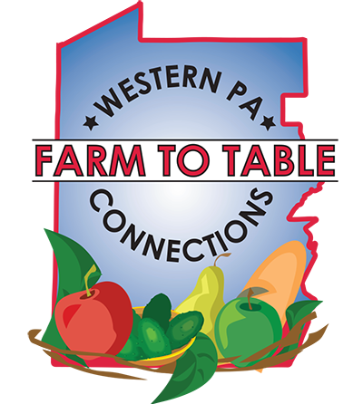
Farm to Table Connections Western PA is a business-to-business networking group for farms, food producers & retailers.
Membership Benefits:
- Usage of Farm to Table Connections logo for 12 months.
- Highlighted listing in Farm to Table Connections Local Food Guide
- Invitation to all Farm to Table Connections Lunch & Learns
- Free vending opportunities at Farm to Table Local Food Tastings
- Supporting Consumers receive free ticket to all Farm to Table Local Food Tastings for 12 months
- Inclusion in social media & TV, radio, print ads throughout 12 months.
- Inclusion in American HealthCare Group wellness events

PLEASE RETURN THIS FORM OR CONTACT US WITH QUESTIONS:
Erin Hart, Director, American HealthCare Group/Farm to Table Pittsburgh
Phone: 412-563-5823 Fax: 412-563-8319
Email: ehart@american-healthcare.net
Mail: 1910 Cochran Road, Manor Oak One, Suite 405, Pittsburgh, PA 15220

