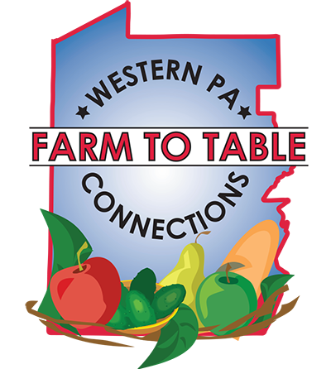
Farm to Table Connections Western PA Membership Information
Our network of farms, food producers, and retailers in connection with the scope of consumers we reach on a daily basis has put us in a position to be a cheerleader for products and services that are locally grown and produced.
We want to offer you the opportunity to be a part of our consumer reach network and media promotions that will help grow your revenue, reach a new audience, and achieve your business goals.
Farm to Table Connections of Western PA is a business-to-business networking group for farms, food producers & retailers that will:
- Generate more demand for local farm products and/or locally produced food
- Provide opportunities for business-to-business relationships to develop
- Work with organizations such as tourist bureaus, farmers markets, farm cooperatives, community development organizations and county fairs throughout this region to promote the existing activities & events that promote local food.
- Work with existing, successful regional events to include a local food component and bring farms & local food business to sell products.
- Organize Farm to Table Connections Lunch & Learns where businesses come together to learn about each other’s products.
- Secure shelving labeled “Farm to Table Connections of Western PA” in retail outlets throughout the region (grocery stores, coffee shops, convenience stores, etc)
- Organize community events such as farm tours and food/beverage tastings to promote local farms and food products.

Food Business Categories

- Bakeries
- Breweries
- Butchers
- Caterers
- Chefs
- Commercial Kitchens/Co-packing
- CSA’s
- Distilleries
- Events that promote local food
- Farm Stores
- Farmers Markets
- Farms
- Food aggregators
- Food producers
- Growers
- Food Marketing professionals
- Media groups that write about food
- Meaderies
- Restaurants
- Transportation/Logistics organizations
- Wineries
- Locally owned retailers
  - Coffee shops
  - Grocery stores
  - Convenience stores

Farm to Table Connections of Western PA Lunch & Learns & Business Networking events
This popular series brings together consumers, farms, food producers and a variety of other industry professionals for lunch & opportunity to introduce your product to the group. The venues vary and are held throughout the Western PA region. All businesses should bring samples & order forms! We’ve held hundreds of these events since 2011. Starting in 2018, Members pay $10; non-members pay $25.

Benefits of Yearly Membership
- Usage of Farm to Table Connections of Western PA logo on packaging & products
- Highlighted listing in the Farm to Table Connections Local Food Guide: https://farmtotablepa.com/local-food-guide
- Invitation to all Farm to Table Connections Lunch & Learns to introduce your products to attendees (both businesses & consumers)
- Free vending opportunities at select Farm to Table Pittsburgh Local Food Tastings
- Digital Placement of member businesses – 2 dedicated posts/year.
  - Social media accounts
    - Facebook, Instagram, Linked In, Pinterest, Twitter, You Tube, Snapchat
    - Access to 50,000+ followers

Additional Benefits
- Discounted pricing:
  - Food safety certifications & trainings
  - Marketing & social media trainings
  - Template contracts for selling & buying
  - Vendor opportunities at AHG/FTT events
  - Advertising on Farm to Table digital platforms, including sponsored boosts in local zip codes on Facebook & Instagram & E-mail newsletter – over 26,500 recipients

- Inclusion in ongoing media buys & opportunity to partner
  - Pittsburgh Today Live – bi-weekly segment
  - 2 page spread in Table Magazine
  - 2 page spread in Pittsburgh Magazine
  - Advertising campaigns to promote events

- Inclusion in American HealthCare Group tabling at events through inclusion of marketing collateral during tabling events or on-site opportunities such as providing catering/food/beverage for events.
  - State-wide Housing Conferences:
    - Pennsylvania Housing Finance Agency (PHFA) Multifamily Housing
    - PHFA Housing Forum
    - Professional Affordable Housing Management Association (PAHMA)
    - Pennsylvania Association of Housing and Redevelopment Authorities (PAHRA)
  - State-wide Agriculture Conferences
    - Pennsylvania Association for Sustainable Agriculture (PASA)
    - PA Women’s Agricultural Network (PA WGN)
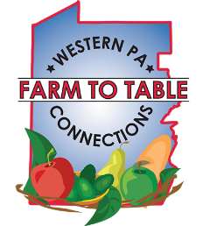
  - PA Farm Show
  - Regional Human Resource Conferences

- Event placement at American HealthCare Group/Farm to Table Pittsburgh events
  - Annual Farm to Table Local Food Conference exhibiting & program advertising
    - Photography session with event photographer including digital images
  - Annual Farm to Table Harvest Tasting
  - Annual American HealthCare Group School Wellness Symposium
  - Ongoing Farm to Table Local Food Tasting Partnerships/Fundraisers for non-profits – support for organization’s events.
  - Ongoing health & wellness events at school districts, municipalities, employer groups, affordable housing communities and community groups – 250+/year throughout region
  - Ongoing Farmers Market on Wheels program
    - Program roll out to area affordable housing communities
    - Develop corporate relationships in region
  - Where to Turn Resource Fair – 3/year at Rivers Club and David L. Lawrence Convention Center

Frequently Asked Questions
- Does my business have to be based in Western PA? No, but you have to be able to sell your product in this region. For example, distilleries in Eastern PA can sell through the Wine & Spirits stores. Or farms in Maryland that sell products in Western PA can join.
- What types of membership are there?
  - Business memberships - Any farm, farmers market or food business based in Western PA that sells local products or wants to source local products for their value-added item.
  - Events – all local food related events or events that include a local food component can be a member.
  - Retailers – all businesses that will provide Farm to Table Connections of Western PA shelving/space for local products.
  - Consumer memberships – includes tickets to all Farm to Table tasting events and conferences for 1 year.
  - Corporate sponsorships – organizations that want to support the efforts of the network. These sponsors will also receive a certain number of free tickets to tasting events & conferences.
- What are the annual membership dues used for? Advertising the brand on TV, radio, print, digital throughout the region. The TV markets are Erie, Johnstown/Altoona & Pittsburgh. Additionally, staff time to organize events, maintain records, place social media posts.
- What is happening to Farm to Table Pittsburgh? This brand will continue to exist in the form of the annual Harvest Tasting events and the Farm to Table Pittsburgh Local Food Conference.
- When does my membership begin? It starts as soon as we receive your application and payment. It lasts for 12 months and renews each year.

