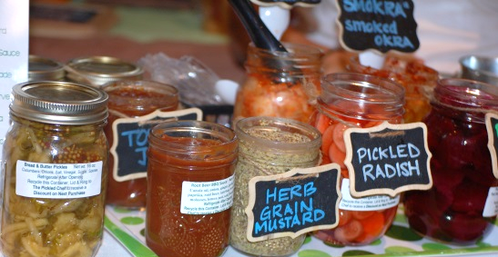
You’re invited to be a vendor at the 7th Annual Farm to Table Harvest Tasting!
The Farm to Table Tasting events are casual gatherings that allow consumers to experience first-hand the quality and diversity of locally grown, produced and prepared food. These are great events to meet customers who value their food and are excited to learn how to access local food and beverages. The atmosphere is relaxing: music and local food conversation abounds.

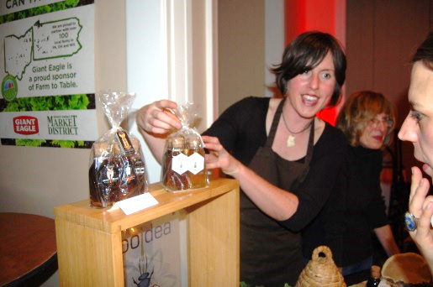
PARTICIPATE IN THE TASTING: If you are a grower or producer of local food, wine, beer or spirits you can sign up to participate in the Harvest Tasting at no cost. You can sell packaged food, products, gift certificates, etc. at the event. You must provide (500) small tastings to the attendees. If you are a non-food vendor, call for sponsorship opportunities.

VENDOR REGISTRATION INCLUDES:
- (1) Exhibit Table and (2) Chairs
- Listing in Event Program
- Live Link on Website

ADVERTISE IN EVENT PROGRAM Get your business name in front of everyone at the tasting with a program ad. You can advertise without being a vendor, too. Full page ads start at $500; half page ads start at $275.

EXHIBITOR INFORMATION: Please list all information as you would like it to be presented in the Event Program.
PROGRAM LISTING:
Company Name: __________________________________ Phone: ___________________ City/State: _____________

ONSITE CONTACT INFO:
Contact Name: __________________________________________ Phone: ___________________________________
Contact Email: _________________________________________ Website:______________________________________
# of Tables (One 8’ Table is Provided. Additional Tables $25/each): __________ # of Chairs:__________ # of Attendees at table: __________ Electricity Needed ($100/vendor)? YES: ______ NO: _______

Other Needs: _____________________________________________________________________________________________________

Menu Item(s) to be available at the tasting and printed in program:

_______________________________________________________________________________________________________

FOOD VENDORS are expected to supply any paper products needed to serve your food/beverage tasting sample – i.e. Napkins, plates, cups, spoons, ice etc. At least 500 samples should be available for the tasting. Be creative and think of sustainable serving options like lettuce leaves or biodegradable cutlery. Tasting Vendors will need to provide me with the following which I will submit to the venue by no later than October 19, 2018:

- Certificate of Insurance
- Release and Waiver Form
- Vendor Agreement
- Adherence to venue Rules and Regulations

PARTICIPATING WINERIES, BREWERIES and DISTILLERIES are expected to supply any paper products needed to serve your food/beverage tasting sample – i.e. Napkins, plates, cups, spoons, ice etc. At least 500 samples should be available for the tasting. Be creative and think of sustainable serving options. You will need to provide me with the following which I will submit to the venue by no later than October 19, 2018:

- Certificate of Insurance
- PLCB Temporary License (The event type is a Farmers’ Market)
- Release and Waiver Form
- Vendor Agreement
- Adherence to venue Rules and Regulations

PLEASE RETURN THIS FORM OR CONTACT US WITH QUESTIONS:
Carla Clipper, Event Manager, American HealthCare Group/Farm to Table Western PA
Phone: 412-563-5823
Fax: 412-563-8319
Email: cclipper@american-healthcare.net
Mail: 1910 Cochran Road, Manor Oak One, Suite 405, Pittsburgh, PA 15220

PAYMENT FOR ADVERTISEMENTS, SPONSORSHIPS, ELECTRIC & ADDITIONAL TABLES:
Payment is due when you submit this contract. If payment has been received, and a paid exhibitor must cancel; no refund will be issued. If a vendor is late to an event without prior notice, the reserved table may or may not be available upon arrival

Choose your Payment Method: _____ Check enclosed (payable to American HealthCare Group, LLC)
_____ Credit Card ___Visa ____AmEx ____MC ____Discover Security Code on back: ___________
Credit Card Number: _______________________________________________ Expiration Date: __________________
Credit Card Payment address (No PO Box): _________________________________________ ZIP: ________________
Cardholder Signature: X_________________________________________________________________________________________

