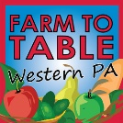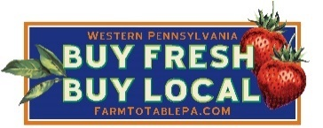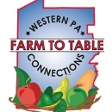

2019 – 2020 Farm to Table Western PA Vendor Agreement

Farm/Company: ________________________________________________ Contact: ___________________________________________
Day of Event Phone #: ______________________________ Email: __________________________________________

Phone/Address for Event Programs: _________________________________________________________________________

Description of table presentation:_______________________________________________________________________________
Electricity (there may be a cost): Yes______ No ______ # of tables needed: ________ # of chairs needed: _______

Event Name | Dates | Venue | Neighborhood | Time | Event Numbers | Vendors Needed | Speakers/Demos Needed | Vendor Fee | Total Fee
Mother Earth News Fair | 9/ 13 – 9/15/2019 | Seven Springs Resort | Seven Springs | All Day | 15,000 | Yes | Yes | $150/Day; $300/Weekend
Harvest of Health Wellness Expo | 10/ 19/ 2019 | Pittsburgh Airport Marriott | Moon Township, PA | 10 am-2 pm | 2500 | Yes | Yes | No Fee
Farm to Table Harvest Tasting | 11/9/2019 | Voodoo Brewing | Meadville, PA | 1 – 4 pm | 200 | Yes | No | No Fee
Farm to Table Harvest Tasting | 11/2019 | TBD | Allegheny County | 3 - 6 pm | 400 | Yes | Yes | No Fee
Pennsylvania Farm Show | 1/2020 | PA Farm Show Complex | Harrisburg | All Day |  | No | Yes | No Fee
Farm to Table Local Food Conference | 3/6 – 3/15/2020 | David L. Lawrence Convention Center | Pittsburgh | All Day | 300,000 | Yes | Yes | $400 - $600/weekend or $800 - $1,200 for 10 days
Total: ____
For Events with multiple dates, please indicate days of the week when you will be vending: _________________________________
_________________________________________________________________________________________________________

Pay with Check: (please make checks payable to (Farm to Table Western PA)

Pay with Credit: Visa, MC, American Express Card Number: __________________________________ Exp Date: ______________

Name on Card & Security Code: _______________________________________________________________________________

Billing Address for Credit Card:_________________________________________________________________________________
Sign & Return Agreement:
I, the undersigned, hereby make application for exhibit space at the event(s) listed above. I agree to be at the above listed event(s) at the above listed date(s) and time(s) or be charged a fee of $50 unless I cancel the event 2days prior.
Name (please print) Signature: * _____________________________________________________________ Date:_______________

