WESTERN PA LOCAL FOOD GUIDE
CALL FOR SUBMISSIONS

We’re excited to be publishing our 2nd annual Western PA Local Food Guide on January 1, 2020 in time for the PA Farm Show! This directory of farms, farmers markets, CSAs, etc. will also contain local food tips, hacks & know how from farms, food businesses and food resource organizations. We help consumers connect to tools and resources to know how and where to access local, real, healthy food year-round.
Check out the 2019 edition here: https://farmtotablepa.com/local-food-guide/

You’re invited to submit articles, pictures, recipes or other interesting content that will help consumers to connect to local, real, fresh healthy food. There is no cost to submit content. Advertising rates on are the next page.

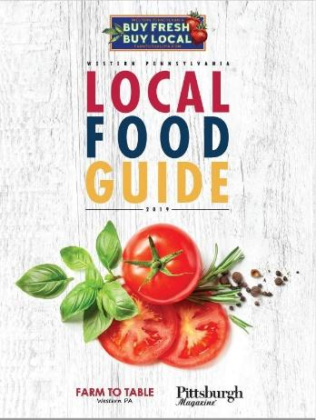
Food pictures should be REAL - not pictures of food that was sprayed with lacquer or made with ingredients that are inventions. Our tagline is Keep it Real, Keep it Local!

We’ll be distributing 60,000 through the following channels:

- Pittsburgh Home & Garden Show, March 6 – 15, 2020
- Direct mail to 20,000+ subscribers
- American HealthCare Group health & wellness events, 400+ in 2020
- Farmers Market tastings, throughout Western PA region, 10+ in 2020
- Farm to Table Connections Lunch & Learns throughout Western PA region, 12+ in 2020
- Regional events: Mother Earth News Fair, County Fairs, affordable housing conferences, agriculture events

Content Creator: ___________________________________________________________________________

Contact information to be printed in Local Food Guide (Title, Business/Organization, City, State): ______________________________________________________________________________________________________________________________________________________________________________________________

Title/topics for Table of Contents/Index: _______________________________________________________________________________________________
_______________________________________________________________________________________________

List of Attachments:
- ______________________________________
- ______________________________________
- ______________________________________
- ______________________________________

Please return form by November 1, 2019. Space cannot be reserved after November 1, 2019. Email is preferable, I will confirm when I receive your file. Not all submissions are guaranteed to be published. You will receive written notification after December 15 if your material will appear in the Local Food Guide.

Costs for Advertisements
Non profits receive 1 full page ad to highlight their programs for 2020. NO COST

Businesses - Advertisements
- Back Cover $7,500
- Inside back cover $6,500
- Full page $2,500
- Half page $1,500
- Quarter page $1,000
- Business card $750

Sizes are width x height:

Full = 8.25” x 10.875” (with bleed, 8.5” x 11.125")
1/2 = 7” x 4.75”, horizontal or 4.75” x 7.1875” vertical
1/4 = 3.5” x 4.75”
Biz card size = 2.25” x 4.75”, vertical or 4.75” x 2.25”, horizontal

All artwork due by November 8, 2019.

Submit competed form: Erin Hart
ehart@american-healthcare.net
Fax: (412)563-8319
Farm to Table Western PA
733 Washington Road, Suite 102
Pittsburgh, PA 15228

