Farm to Table Buy Local
Food Guide Advertising & Underwriting Sponsorships

Western PA Local Food Guide Advertising
This directory of 750+ farms, farmers markets, CSAs, etc. contains local food tips, hacks & know how from farms, food businesses and food resource organizations. We help consumers connect to tools and resources to know how and where to access local, real, healthy food year-round. Ads and advertisers are subject to approval.
Check out past editions: https://farmtotablepa.com/local-food-guide/

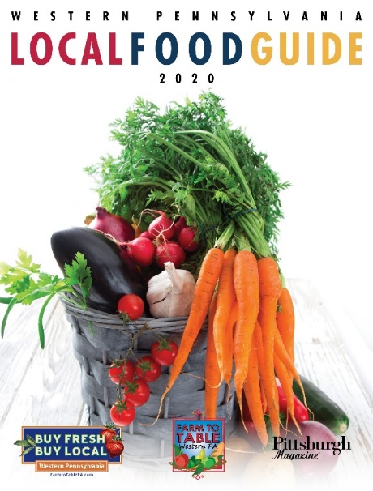
Advertising Costs:
Inside Front/Back Cover $6,500
Full Page Ad $4,000
Half Page Ad $2,500
Farms Biz Card Ad $750

Sizes are width x height:
Full = 8.25” x 10.875” (with bleed, 8.5” x 11.125")
1/2 = 7” x 4.75”, horizontal or 4.75” x 7.1875” vertical
1/4 = 3.5” x 4.75”
Biz card size = 2.25” x 4.75”, vertical or 4.75” x 2.25”, horizontal

Distribution of 60,000 through the following channels:
- Pittsburgh Home & Garden Show – October 6 – 8, 2023
- Pittsburgh Home & Garden Show, March 1 – 10, 2024
- Direct mail to 20,000+ Farm to Table subscribers
- Farmers Market tastings, throughout Western PA region, 10+ in 2024
- Farm to Table Connections Lunch & Learns throughout Western PA region, 12+ in 2024
- State wide Pennsylvania events: Mother Earth News Fair (Erie, PA), human resource conferences, affordable housing conferences, agriculture events

Farm to Table Buy Local Underwriting Sponsorship
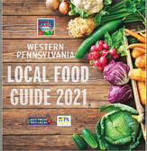
Underwriters will have a customized package of benefits from Farm to Table Buy Local, including inclusion in Western PA Local Food Guide, signature events and ongoing public relations/media campaign.

Underwriting Costs & Benefits: $25,000 +
- 32,000 - Buy Fresh Buy Local e-newsletter
- 150,000 - Printed & digital reach w/media partners Pittsburgh Magazine & Table Magazine
- 40,000 + social media - Facebook, Twitter, Instagram, LinkedIn
- 5,000 - Farm to Table Organic Gardening classes with Doug Oster
- 350,000 - Event attendance by Farm to Table staff at farmers markets, large community events, cooking clubs, community gardens, Farm to School programs, Farm to Table networking events
Advertiser/Sponsor: ___________________________________________________________________________

Contact information (Title, Business/Organization, City, State, Phone/Email): __________________________________________________________________________________________________________________________________________________________________________________________________________________________________________

Please return form by June 30, 2023. Space cannot be reserved after August 31, 2023. Not all submissions are guaranteed to be published. All artwork due by September 15, 2023. 50% payment is due at time of receipt to hold space. You will receive written notification immediately if your advertisement will not appear in the Local Food Guide.

Contact:
Erin Hart, Executive Director
412-657-3028
ehart@american-healthcare.net
Farm to Table Buy Local
733 Washington Road, Suite 102
Pittsburgh, PA 15228

